
Year 11 General Human Biology
Task 2: Supervised written – Cell reproduction, reproductive systems and pregnancy (10%)

RESULT
/ 37

Task 2

TYPE: Supervised Written
CONTENT: Cell reproduction, reproductive systems and pregnancy

WEIGHTING: 10%

Student Name: MARKING KEY
Due date: ___ / ___ / ______
Teacher: Mrs Cunningham

CONDITIONS:
Must be completed under test conditions in class. This task will be competed individually.
50 minutes allocated
37 Marks

TASK DETAILS:
This task contains four questions with a number of parts to assess the student’s understanding of the content from the science understanding topics cell reproduction, reproductive systems and pregnancy.
Notes/reference materials may not be used during this task.
This task contains a number of question types. You could be required to:
- provide single word, sentence or short paragraph responses
- provide responses making connections, drawing conclusions, constructing arguments, analysing and/or evaluating information.
Your responses may incorporate labelled diagrams or tables with explanatory notes.

Answer all questions in the spaces provided. (TOTAL 37 marks)

Question 1 (TOTAL 7 marks)

The diagram below shows the structures of deoxyribose nucleic acid (DNA).
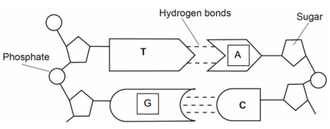

- On the diagram above, write the missing base to complete each base pair. (2 marks)
T pairs with A (1)
C pairs with G (1)

- On the diagram above, label the following structures:

- a sugar molecule correctly labels a sugar molecule (1)
- a phosphate molecule correctly labels a phosphate molecule (1)
- hydrogen bonds. correctly labels hydrogen bonds (1)

- Circle the correct answer to complete the sentences below. (2 marks)

- The double helix describes the shape of

DNA (1) chromosomes

- The region on a chromosome that contains the code for a trait an organism inherits is a

gene (1) mitosis

Question 2 (TOTAL 11 marks)

Cell division plays a critical role in cellular growth, development and reproduction.
The diagram below shows the phases of mitosis, however, they are not in the correct order.
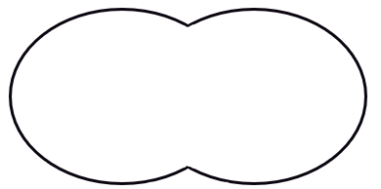
D
C
A
B
E

- List the letters A to E in the order that represents the phases of mitosis correctly. (1 mark)
C E D A B (1 – to get mark must have ALL in correct order) (no half marks)

Sexual reproduction requires the production of gametes
- Define the term ‘gamete’. (1 mark)
A sex / reproductive cell (1)

Gametes are produced by the process of meiosis. This process produces a cell that is haploid.
- State what the term ‘haploid’ means. (1 mark)
A single set of chromosomes (1)

Human cells contain two sex chromosomes and 22 autosomal chromosomes.
- Use the information above about humans to complete the following table. (2 marks)
 | Adult female
Total number of chromosomes in each body cell | 46 (1)
Total number of chromosomes in each gamete | 23 (1)

- Use the table below to outline three differences between mitosis and meiosis. (6 marks)
Only one mark is awarded for each difference if a fact about mitosis or meiosis is provided without a complementary difference for the other.
To get 2 marks per row – both mitosis and meiosis MUST have a difference written in each box provided.
Mitosis | Meiosis
Produces two (daughter) cells | Produces four (daughter) cells
(daughter) cells are identical to parent cell | (daughter cells are different to patent cell
Cells produced are diploid | Cells produced are haploid
Cells produced for growth and repair | Produces gametes

Accept other relevant answers

Question 3 (TOTAL 13 marks)

The diagram below shows the structure of the male reproductive system.
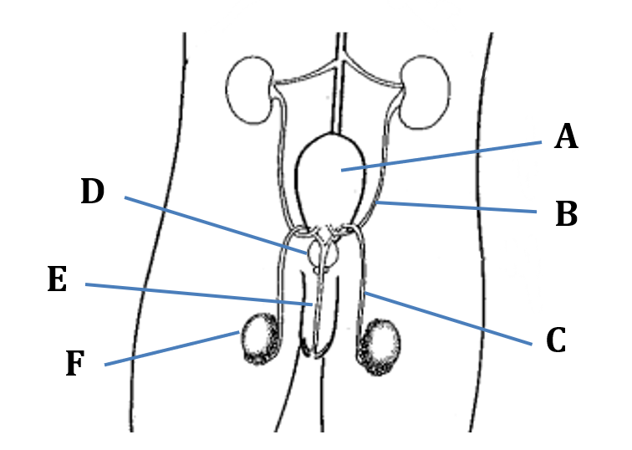
- Refer to the diagram above to complete the table below. (4 marks)
Label | Name of structure | Function of structure
A | Bladder (1)
D | Prostate Gland (1)
C (1) | Vas deferens (1) | Carries sperm to the urethra

Both males and females produce follicle stimulating hormone (FSH) and luteinising hormone (LH).
- Which organ is responsible for the production of these hormones? (1 mark)
Anterior pituitary gland (can accept pituitary gland) (1)
- Identifying the target organ or cells for each of these hormones and state their effect on the male reproductive system. Write your answers in the table below. (4 marks)
Hormone | Target organ or cells | Effect on male reproductive system
FSH | targets the seminiferous tubules in the testes (1) | stimulates the production of sperm (1)
LH | targets the interstitial cells of the testes (1) | stimulates the production of testosterone (1)

Use the key below to answer the following questions (d) and (e).
2n | Total genetic material of a human cell
n | One half to the total genetic material in a human cell

- Choose which of the following representation shows correctly what happens to chromosome numbers during the process of fertilisation. (1 mark)
Option one
n
2n
2n
+

Option two
n
2n
2n
+

Option three
n
n
2n
+

Option four
4n
2n
2n
+

The correct option is:
Option three / 3 (1)
- Justify your choice in question (d). (3 marks)
haploid number/gametes contain half the total genetic material (n) (1)
fertilisation is fusing of two gametes/haploid cells (1)
to create a diploid cell/fertilised egg (2n) (1)

Question 4 (TOTAL 6 marks)

The following diagram is that of a pregnancy at approximately 18 weeks gestation.
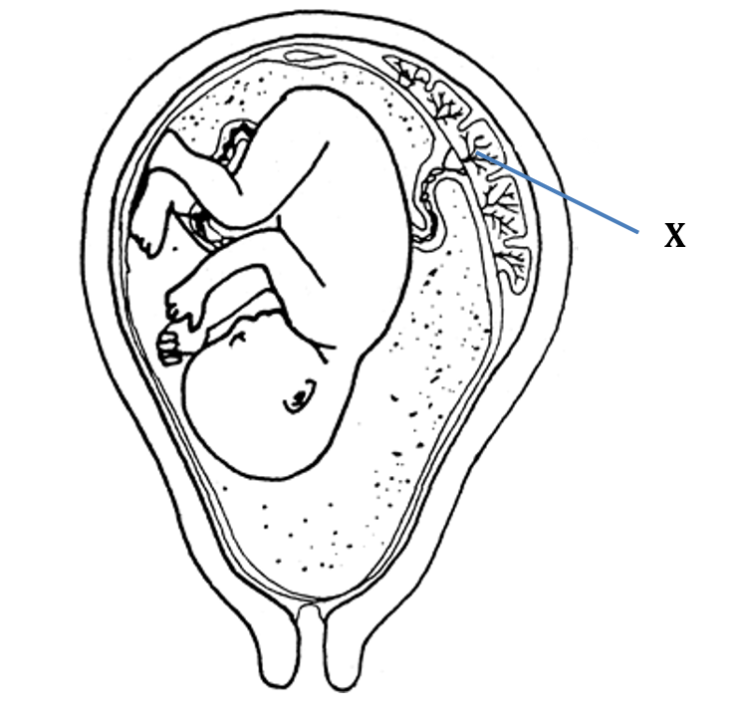
- Circle the anatomical term that best describes the baby at this stage of gestation. (1 mark)

blastocyst embryo foetus – (1)

- Identify structure X. (1 mark)
Placenta (1)

- Explain how structure X is suited to the function it performs. (4 marks)
Explains any two features (2 x 2 marks)
• large surface area (1) allows for more substances to be exchanged (1)
• highly vascular/many capillaries/more blood (1) to bring more requirements and remove wastes (1)
• close association between maternal and foetal tissues (1) for rapid exchange of materials (1)

Accept other relevant answers

END OF ASSESSMENT

